Multi-Store Retail Performance Analysis

Business Problem
Retail decision-makers need a clear way to compare sales performance across stores and product departments. Without a consolidated report, it can be difficult to identify which stores generate the most revenue, which departments drive overall performance, and how sales change overtime.

Project Objective
The objective of this project was to analyze historical Walmart retail sales across three Texas stores and two product departments from May 2014 to May 2016. The analysis focused on total revenue, units sold, average selling price, monthly revenue trends, and performance differences between stores and departments.

Tools Used
- MySQL Workbench: Used to query, organize, and summarize the retail sales data.
- Power Query: Used to clean the data, rename fields, and standardize store and department values.
- Power BI Desktop: Used to create calculations, interactive visuals, slicers, and the final two-page dashboard.
Data Preparation and Cleaning
- Reviewed the retail sales data and confirmed the reporting period from May 2014 to May 2016.
- Checked the fields used for dates, stores, departments, units sold, prices, and revenue.
- Standardized department names by changing FOODS_1 to Foods and HOUSEHOLD_1 to Household.
- Created a month-based date field to support the monthly revenue trend.
- Renamed technical field labels to clearer business-friendly names such as Store, Department, and Month.
- Verified that revenue, units sold, and average selling price were displayed using consistent number and currency formatting.
Dashboard Development
- Created an Executive Overview page showing total revenue, total units sold, average selling price, monthly revenue trends, and revenue comparisons by store and department.
- Created a Store and Department Performance page to compare revenue, units sold, and average selling price across the three Texas stores.
- Added interactive Store and Department slicers to allow users to explore specific areas of performance.
- Used KPI cards, bar charts, stacked column charts, a line chart, and a matrix to present the results clearly.
- Added a note explaining that May 2014 and May 2016 contain partial-month data.
Key Findings
- Total revenue reached $7.44 million, with approximately 2.14 million units sold.
- The overall average selling price was $3.48 per unit.
- TX_3 generated the highest revenue at approximately $2.63 million.
- The Household department generated $5.89 million, compared with $1.55 million for Foods.
- Household revenue was approximately 3.8 times higher than Foods revenue.
- The Household department also had a higher average selling price across all three stores.
- Revenue changed over time, while the first and last months represented partial reporting periods.
Business Recommendations
- Maintain strong inventory availability for the Household department because it generates most of the total revenue.
- Review the sales practices and product mix at TX_3 to identify strategies that could improve performance at TX_1 and TX_2.
- Investigate opportunities to increase Foods revenue through pricing, promotions, or product assortment changes.
- Continue monitoring average selling price by store and department to identify pricing differences and changes in customer purchasing patterns.
- Account for the partial reporting periods in May 2014 and May 2016 when evaluating monthly revenue trends.
Dashboard Screenshots
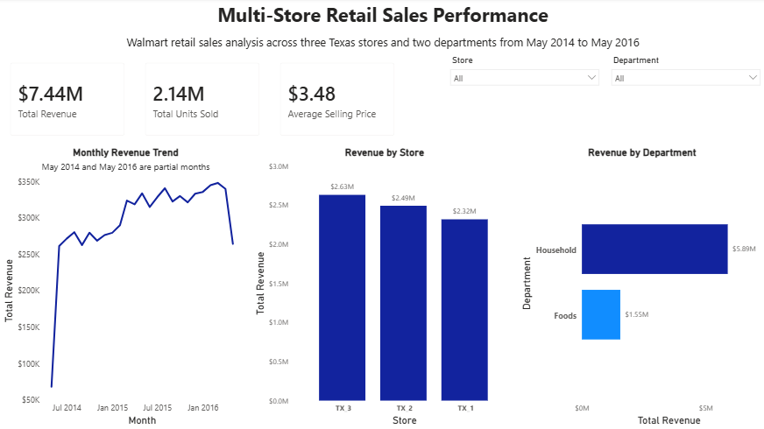
Figure 1. Executive Overview

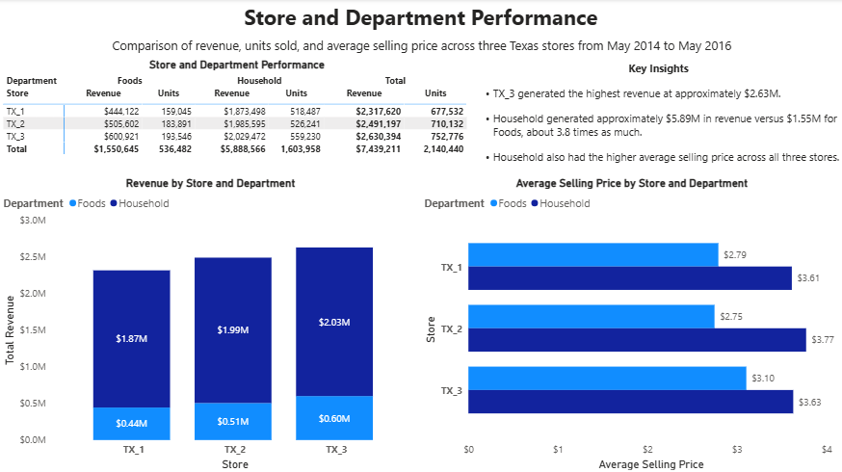
Figure 2. Store and Department Performance

